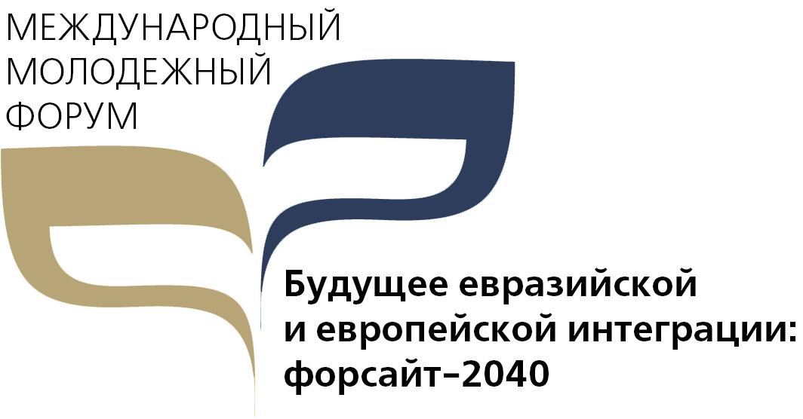
Application Form
for Participation in the Forum
qualifying round

4-8 December 2017, Austria
In order to form an effective make-up of participants in the Forum it is held a competitive selection of the incoming application forms on the basis of information submitted that characterizes personal, creative, business, intellectual qualities and competence of prospective participants.
Stages of competitive selection:
1. Questioning- analysis of the compliance of the educational base, creative potential and practical experience to the objectives of the Forum
2. Testing of personal, creative, business, and intellectual competences
Last name First name Patronymic ________________________________________________________
Date of Birth
Home address
Tel . |  |  |  |  |  | E-mail:
Travel passport  series |  |  |  |  | No. |  |  |  | Date of issue and Date of expiry
Place of issue and issuing authority

Education

Basic
Name of education institution
Year of study
Department/University profile
Specialization/department profile
Years of attendance
State if any additional education
(courses, trainings, master classes, etc): _____________________________________________________________
Where and when the training was conducted, the type and name of the educational institution
Existing diplomas and certificates:
Participation in other youth projects
Awards, prizes, grants, scholarships and grants received
Publications, creative works, writings
Knowledge of Russian and English languages and the level of proficiency
Knowledge of special computer programs |  |  |  |  |  |  | .
Experience in project activities
(Give the summary of the project):
 | Why do you want to participate in the Forum?
 | How do you want to contribute?
 | Why are you willing to participate in the Youth Forum?
 | Why do you think the dialogue of young people in Europe and Asia is especially important today?
 | What is the mission of the Forum from your point of view?
 | What can the youth do, or what do you think can be its contribution to the strengthening the Future of the Eurasian and European integration?
 | I participate in the following organizations / associations / projects (what, where, how long?)
 | Most of all I'm interested in the following topics:  (tick off as applicable –but not more than 2 topics) |  |  |  |  |  | Economic integration
 |  |  |  |  |  |  | Security: Building stability and peace
 |  |  |  |  |  |  | Socio-cultural integration
 | I will try to provide the following regional media with information about my participation in the Youth Forum:
 | I do not need a Schengen visa to EU  (check as applicable) |  |  |  |  |  | Yes No
 | Do you prefer regular food  Or vegetarian |  |  |  |  |  | Regular  Vegetarian
 | I found out about the youth forum from:

Application form with a photograph and scan of the first page of travel passport to be sent to the e-mail of the Institute for Economic Strategies: cmps@inesnet.ru
The last date for sending the Preliminary Application Form -30.09.2017!

ATTENTION! The selection of participants - until October 10, 2017.
Information about the winners in the competition will be posted on the websites of the Institute for Economic Strategies (INES) and the International Institute for Applied Systems Analysis, Laxenburg, Austria after October 10, 2017.
All winners will receive invitations.
I hereby give my consent to the organizing committee of the International Youth Forum "The Future of Eurasian and European integration: Foresight-2040":
- for the processing of personal data specified by me in the application of the participant;
- on the using and placement of open-access photo and video footage.
During the Forum, photo and video will be done. Taking part in this event, its participants thus agree for useing and post open-access photo and video footage, incl. for media coverage.

____ September 2017 Print full name: _________________________________Signature1

